Submitted By
Hammad Khurshid
Roll No. 16
Submitted to: Eng Zeeshan Rashid
Software Engineering Technology
University Of Azad Jammu And Kashmir, Muzaffarabad
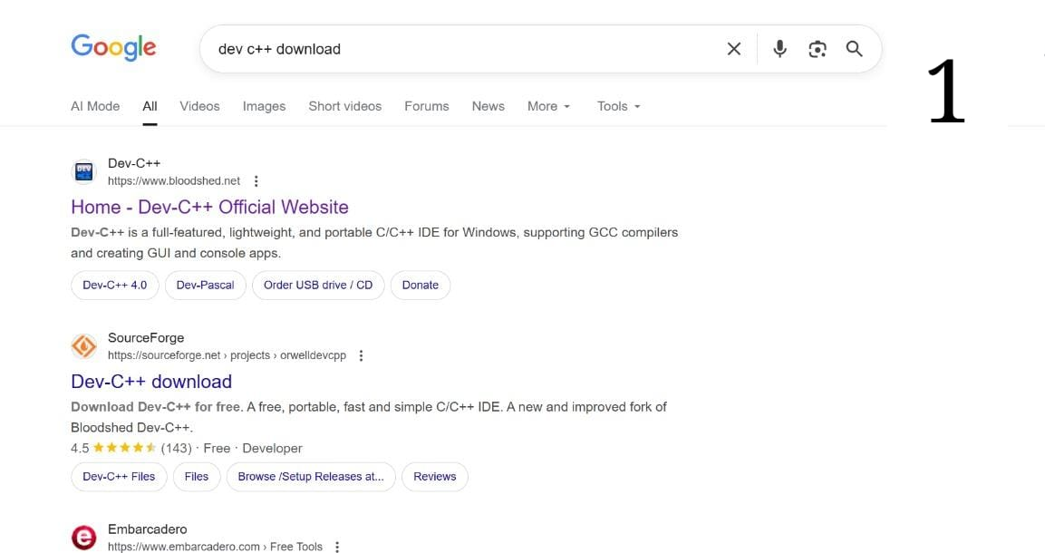
Open Google and type “DevC++ download” in the search bar, then press Enter.

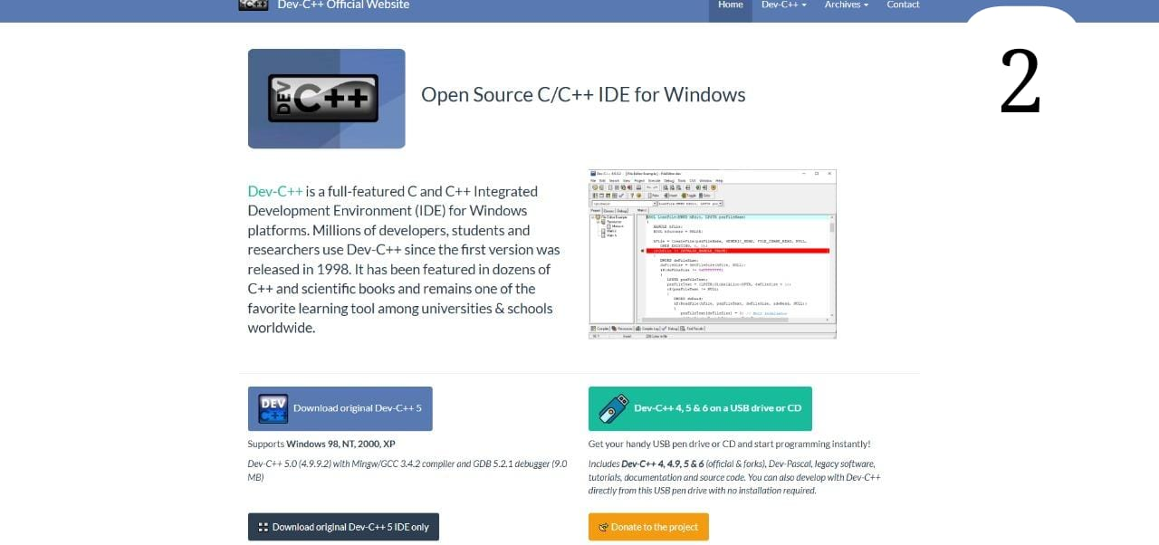
DevC++ is an open-source IDE used to write and run C and C++ programs.

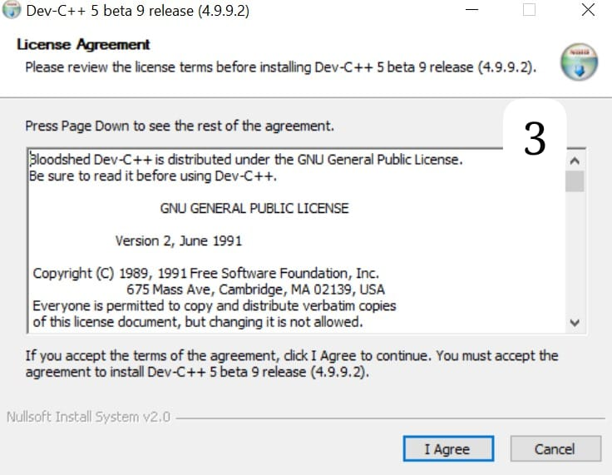
Once the setup opens, a window will appear showing the license terms. Click on “I Agree to continue.
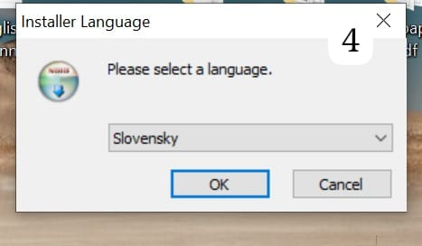
select your language and press OK to continue.
The setup will ask which components you want to install. Keep everything as it is and click Next.
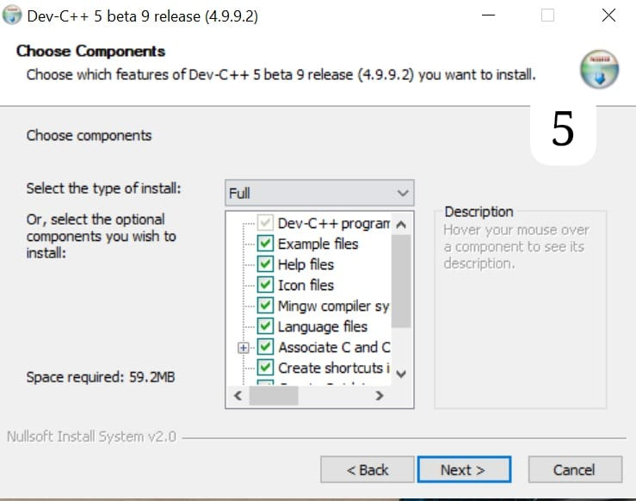

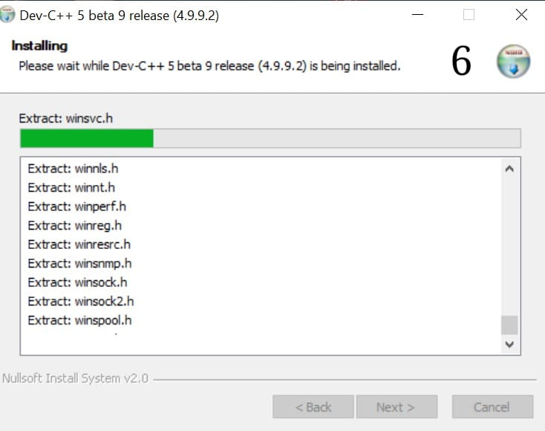
DevC++ is now being installed on your computer. Please wait for a few moments until the
process finishes.
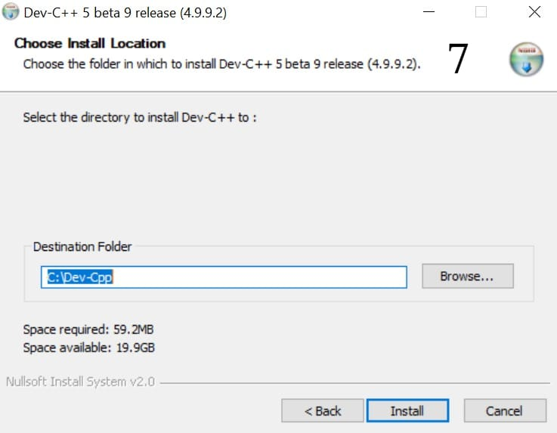
Now choose the installation folder where DevC++ will be installed, then click Install to begian
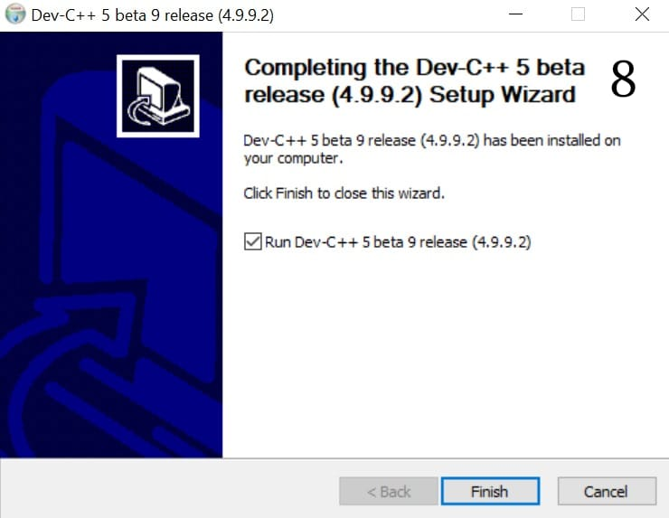
When the installation completes, click on the Finish button to close the setup

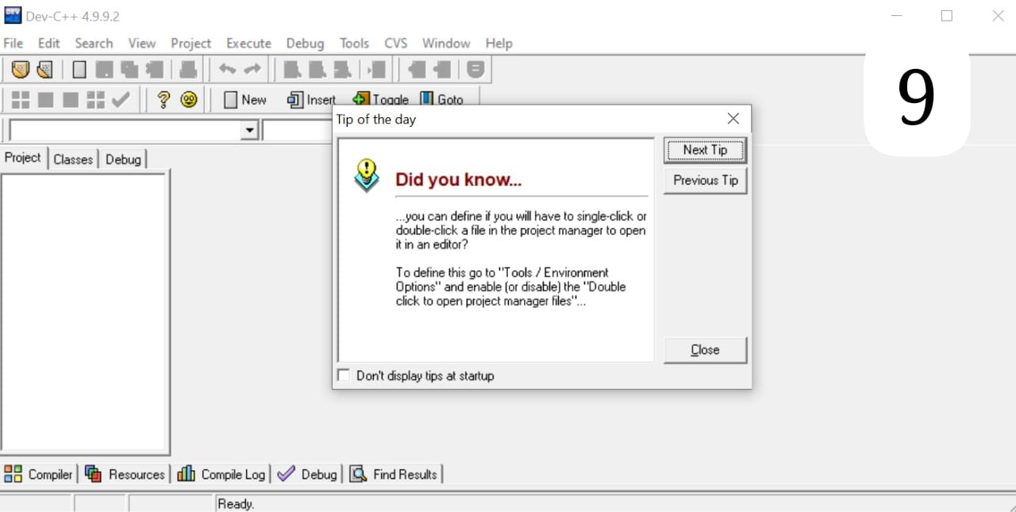
Congratulations! DevC++ is now ready to use. You can start writing your C or C++ programs here.

